Contextual Child Safety Risk Detector
Detecting Children and Household Hazards Using Deep Learning

Simon Ambata  College of Computer Studies  De La Salle University  2401 Taft Avenue, Manila, Philippines  email@email.com | Stephen Co  College of Computer Studies  De La Salle University  2401 Taft Avenue, Manila, Philippines  email@email.com
James Foo  College of Computer Studies  De La Salle University  2401 Taft Avenue, Manila, Philippines  james_foo@dlsu.edu.ph | Nathaniel Tolentino  College of Computer Studies  De La Salle University  2401 Taft Avenue, Manila, Philippines email@email.com

ABSTRACT
Young children left briefly unattended can reach household hazards such as knives, tools or small swallowable objects. Existing home monitoring products detect movement into manually configured zones, but have no notion of which objects are dangerous or where those objects currently are. This work builds and evaluates a pipeline that detects children and hazardous objects using two separately trained nano-scale object detectors and combines their outputs with a geometric proximity rule, producing a Safe or Unsafe label for each frame. The two detectors reach 0.967 and 0.551 mean average precision at an intersection-over-union threshold of 0.5 on held-out test data, and run together in 7.2 milliseconds per frame, comfortably faster than real time. The proximity rule reaches a balanced accuracy of 0.595 on a held-out evaluation set, but its confidence interval includes chance, so the geometric stage is not confirmed as effective. Detection failure, not the choice of distance measure, is shown to be the dominant error source. Hyperparameter tuning selected on a shortened training schedule transferred poorly and reduced final accuracy.
CCS CONCEPTS
• Insert CCS text here • Insert CCS text here • Insert CCS text here
KEYWORDS
Object detection, YOLOv8, computer vision, child safety, proximity estimation, model fusion
1 Introduction
A child alone in a kitchen for a few minutes is enough time for a serious injury: a knife left within reach, a tool on a low shelf, or a coin small enough to swallow. This risk has driven a large consumer market in smart home cameras and baby monitors. Products in this category typically offer a “danger zone” feature, in which a caregiver manually marks a region of the home — near a staircase, a stove, or a pool — and receives an alert when the child enters it.
That design has a structural limitation. The zone is fixed at configuration time and the system reasons only about the child’s coordinates relative to it. It has no representation of what is dangerous, so a knife left on a low table outside the marked region produces no alert, while a child playing safely inside a marked region produces a false one. The hazard itself is invisible to the system. This work addresses that limitation by detecting the hazardous object as well as the child, and computing risk from the measured distance between them, with no manual configuration.
Research question. The pipeline needs two detection capabilities: locating children, and locating a diverse set of household hazards. These can be learned by one multi-class model or by two independently trained specialists. The latter avoids forcing a single network to share capacity between visually dissimilar tasks and lets each detector be configured independently, but requires running two models per frame. We ask whether two independently trained specialist detectors, combined only at the output level by a geometric rule, form a workable child safety risk detector, and at what computational cost.
An earlier framing asked whether this design outperforms a unified multi-class model. That comparison was abandoned because it cannot be answered with the available evidence: the published unified-model figure was obtained on a different dataset, with different hazard classes, using a substantially larger network. Establishing superiority would require training a unified model on the union of our own datasets as an internal control, which was outside the compute budget. The supportable claim is the weaker one: that the specialists perform competitively with published figures.
Contributions.
• A complete, reproducible two-detector pipeline with an output-level proximity rule, evaluated end to end on held-out data, including the cost of running both detectors per frame.
• An honest negative result on the risk-classification stage: its held-out confidence interval includes chance, and detection failure rather than distance measurement is identified as the dominant error source.
• Three methodological findings that generalise beyond this application — tuning on a shortened schedule can reduce final accuracy; a sequential ablation can invert when an earlier parameter is corrected; and a widely used framework default silently discards a hyperparameter under tuning.
• A measured account of dataset contamination in a public dataset, with its effect on reported accuracy quantified rather than assumed.
2 Related Work
[To be written. Requires at least eight peer-reviewed papers organised thematically; five are currently available. Themes to cover: automated child-safety monitoring; single-stage object detection and the accuracy/cost trade-off motivating nano-scale models; small-object detection, which is directly relevant since missed small hazards are our dominant failure mode; output-level model fusion versus joint multi-task training; proximity reasoning in safety-critical vision; and dataset contamination. Positioning: this work adopts the detect-then-measure-distance framework of prior child-safety systems but separates detection into two independently trained specialists and evaluates the geometric stage in isolation, which prior work has not done.]
3 Methodology
Architecture. The pipeline has three stages, shown in Figure 1: two parallel detectors and a fusion rule with no learned parameters.
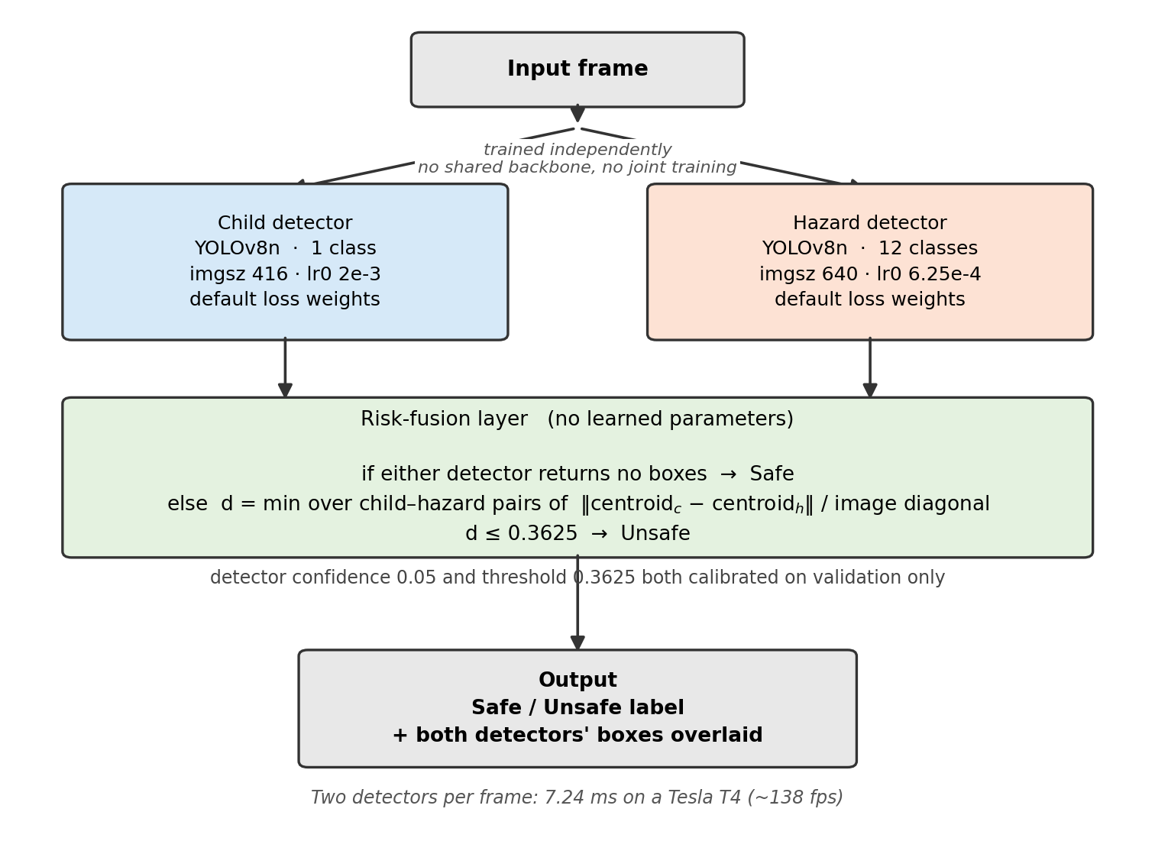
Figure 1: Pipeline architecture. The detectors are trained on separate datasets with no shared weights and no joint training, and use different input resolutions. Fusion is a threshold on normalised centroid distance.
The child detector is a YOLOv8-nano model fine-tuned on a single child class at 416×416. The hazard detector is a separate YOLOv8-nano model fine-tuned on twelve classes — Axe, Chainsaw, Chisel, Coin, Drink, Dumbbell, Fork, Hammer, Knife, Scissors, Screwdriver, Stapler — at 640×640. All twelve collapse to a single hazard category at fusion, but the specific class is retained for display, so the system reports “Knife” rather than “hazard”.
Risk-fusion layer. If either detector returns no boxes the frame is labelled Safe, since a risk assessment requires both objects. Otherwise, for every child–hazard pair the Euclidean distance between box centroids is computed and normalised by the image diagonal, d = ‖c_child − c_hazard‖ / √(W²+H²). The minimum d over all pairs is compared against a calibrated threshold: below it the frame is Unsafe. Normalising by the diagonal makes d dimensionless and comparable across resolutions, which a raw pixel threshold is not.
Design justifications. The child class and the twelve hazard classes differ greatly in scale, appearance and frequency; training them jointly forces one backbone to allocate capacity across both and creates a class-imbalance problem between one common class and twelve rarer ones. Training separately removes that coupling and allows independent configuration — which mattered, since the detectors converged on different optimal resolutions. Keeping fusion parameter-free means the geometric stage can be evaluated in isolation: any failure is attributable to the detectors or the rule, not to a third trained component.
Training procedure. Both detectors are fine-tuned from COCO-pretrained YOLOv8-nano weights for 100 epochs at batch size 16 with default augmentation, using AdamW and the standard YOLOv8 composite loss (box regression, classification, distribution focal loss). The child detector uses an initial learning rate of 2×10⁻³ and the hazard detector 6.25×10⁻⁴, both annealed to 1% of the initial rate over the scheduled epoch count.
These rates come from the framework’s own heuristic for a dataset’s class count. This is worth stating because the framework applies it silently: with the optimizer left at its automatic setting, any user-specified learning rate is discarded and replaced, and the run’s configuration file records the supplied value rather than the one used. This invalidates any hyperparameter search conducted under that setting, so all tuning reported here names the optimizer explicitly.
4 Experimental Setup
Datasets. Two public Roboflow Universe datasets, each used with its creator’s predefined split without reshuffling (Table 1).
 | Child | Hazard
Images | 4,705 | 5,917
Unique source photos | ~649 (≈7 copies) | 3,863 (≈1.5)
Classes | 1 | 12
Train / val / test | 4,080 / 372 / 253 | 4,758 / 773 / 386
Distributed augmentation | salt-and-pepper 5% | 50% h-flip
Table 1: Dataset composition.
Two dataset defects were found and are reported rather than worked around. Filenames in the child dataset encode the source photograph, making duplication checkable: 386 source names span the training and evaluation boundary, and pixel comparison confirms ~17% of validation and ~21% of test are near-duplicates of training images. The effect was measured, not assumed — re-evaluating the same weights on a decontaminated validation subset (313 of 372) gives 0.9465 mAP50 against 0.9548 on the full split, an inflation of 0.008. The contamination is real but small, and the dataset was retained. The hazard dataset is free of cross-split duplication. Separately, the 4,705 child images derive from only ~649 unique photographs, so effective visual diversity is an order of magnitude below the image count.
Hazard classes are heavily imbalanced: validation support ranges from 367 instances (Coin) to 5 (Chisel). Classes below about 30 instances produce per-class figures that move substantially on single detections.
Risk-classification evaluation set. Neither source dataset contains frames with a child and a hazard together, so neither can evaluate fusion. A purpose-built set of 200 composited images was constructed by pasting hazard crops onto held-out child photographs at controlled separations (123 validation / 77 test, split by source photograph). Ground truth uses a reachability criterion — whether the gap between boxes is at most half the child’s box height — deliberately chosen because it is not a rescaling of the distance measure under test, so the evaluation is not circular.
Baselines. The primary baseline is internal: both detectors trained at framework-default hyperparameters with the automatic optimizer for the same 100 epochs. This determines whether tuning helped. Four published systems are used as context; none is directly comparable, and Table 5 records why.
Evaluation metrics. Average precision is the area under the precision–recall curve for a class; mAP is its unweighted mean across classes. mAP50 uses a fixed intersection-over-union threshold of 0.5; mAP50-95 averages over thresholds 0.5 to 0.95 in steps of 0.05 and is therefore more sensitive to localisation precision. Both are reported: mAP50 indicates whether the object is found, mAP50-95 whether it is found accurately. Because mAP is unweighted, a rare class influences the hazard figure as much as a common one.
For risk classification we report balanced accuracy, the mean of the two class recalls, BA = ½(TP/(TP+FN) + TN/(TN+FP)). This is used in preference to plain accuracy because the evaluation set is ~74% Unsafe, so a degenerate always-Unsafe classifier scores 0.740 while contributing nothing; balanced accuracy scores any constant classifier 0.500. Precision, recall and specificity are reported alongside, since a missed hazard and an unnecessary alert carry very different costs. Latency is reported per detector and summed, since both run on every frame.
Implementation. Ultralytics YOLOv8 pinned at 8.4.106; YOLOv8-nano (3.01M parameters, 8.1 GFLOPs); NVIDIA Tesla T4 on Google Colab; 100 epochs at batch 16; AdamW; default loss weights (box 7.5, cls 0.5, dfl 1.5); child at 416 and hazard at 640. Training took 86 and 145 minutes respectively. The version is pinned because minor versions differ in detection-head initialisation, shifting the same weights’ mAP50 by about 0.004 — small, but enough to corrupt an ablation.
Reproducibility. All code, configurations and result files are in the project repository. Both datasets are public and fetched at pinned version numbers so a later re-release cannot silently change the split; two post-download fixes are scripted (the distributed configuration files contain broken relative paths, and the child dataset ships as two classes where the second is mislabelled instances of the first). All runs use seed 0 with deterministic mode; two independently launched runs of one configuration reproduced each other to five decimal places. The final training configuration is embedded in the training script rather than passed on the command line, so a final run cannot silently disagree with the ablations that chose it. Every table and figure is regenerated from the result files by a single script.
5 Results
All development used validation splits. The test splits were used exactly once, at the end, with every parameter fixed in advance.
Main results.
System | Split | mAP50 | mAP50-95
Child detector | child test | 0.9670 | 0.9081
Hazard detector | hazard test | 0.5506 | 0.3958
Table 2: Detector performance on held-out test data.
Risk classification (test) | Value
Balanced accuracy | 0.5947
95% confidence interval | [0.483, 0.707]
Plain accuracy | 0.5974
Unsafe precision / recall | 0.683 / 0.609
Safe recall | 0.581
Confusion TP/FP/FN/TN | 28 / 13 / 18 / 18
Table 3: Risk classification. The interval includes chance (0.500).
The child detector’s test figure exceeds its validation figure (0.967 against 0.955). This is most plausibly contamination rather than generalisation: the child test split carries the highest measured duplication (≈21%, against ≈17% in validation).
Computational cost. Child 3.05 ms and hazard 4.19 ms per image on a T4, giving 7.24 ms per frame for the complete pipeline, about 138 frames per second. Running two specialist detectors instead of one is therefore not a meaningful cost objection at this model scale.
Ablation: input resolution. Each detector was trained at 416, 640 and 832 with all else fixed (Figure 2).
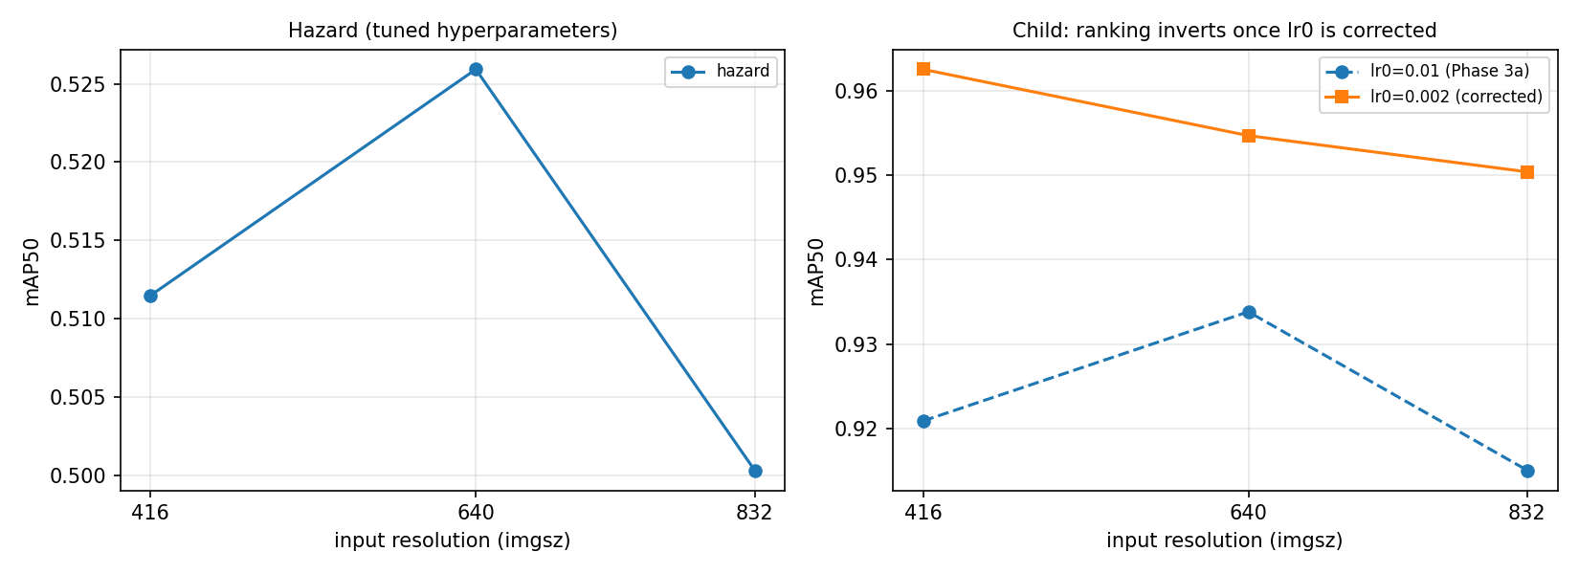
Figure 2: Resolution ablation. Right: the child ranking inverts once the learning rate is corrected — 416 moves from last to first.
imgsz | Hazard | Child (lr 1e-2) | Child (lr 2e-3)
416 | 0.5115 | 0.9209 | 0.9626
640 | 0.5259 | 0.9338 | 0.9547
832 | 0.5003 | 0.9150 | 0.9504
Table 4: Resolution ablation, mAP50, 30 epochs per cell.
Two findings. First, 832 is worse than 640 for both detectors — by 0.034 mAP50-95 in each case — while costing about 1.6× more inference time; since the effect replicates across two independent datasets it is more credible than a single-model result. Second, the child ranking inverts depending on the learning rate. The child detector was never tuned, so the first ablation ran at the framework default of 1×10⁻², under which 640 wins. Repeated at the correct 2×10⁻³, every resolution improves and 416 — previously last — wins on both metrics while running 1.97× faster. The first ablation was internally consistent, so its comparison was not invalid; but it was conducted at a handicapped operating point and produced a confidently wrong answer.
Ablation: optimizer. Each optimizer is given the learning rate appropriate to it rather than a single shared value. Holding one rate fixed does not isolate the optimizer, it measures which optimizer happens to suit that rate — our own tuning data shows the same optimizer scoring 0.2325 mAP50 at one rate and 0.5020 at another. AdamW is best or tied-best in every comparison (hazard 0.5259 against SGD 0.5130 and Adam 0.5181; child 0.9547 against 0.9509 and 0.9528), though the margins of 0.004–0.018 are small.
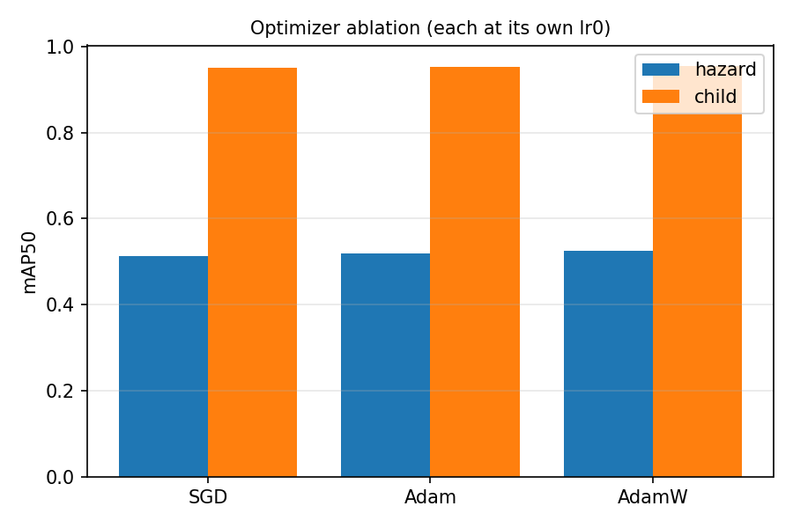
Figure 3: Optimizer ablation, each optimizer at an appropriate learning rate.
Ablation: hyperparameter tuning. An evolutionary search over the initial learning rate and three loss weights ran for six iterations of 20 epochs; the winner was retrained at the full 100 epochs against the untuned baseline.
Hazard configuration | mAP50 | mAP50-95
Framework defaults (baseline) | 0.5657 | 0.4072
Tuned (lr 8.8e-4, box 8.14, cls 0.75, dfl 1.06) | 0.5256 | 0.3913
Difference | −0.0401 | −0.0159
Table 5: Tuning reduced final accuracy.
Tuning made the detector worse, on 10 of 12 classes. Hyperparameters were selected on 20-epoch runs and applied to 100-epoch training; the framework anneals the learning rate across the scheduled epoch count, so a 20-epoch run is fully annealed at its end while a 100-epoch run is only one fifth through its decay. A configuration that converges well under a short schedule is not necessarily best over five times as long. The shipped hazard detector is therefore the untuned baseline. A second limitation: the learning rate dominated the search, moving fitness by 0.170 while the entire spread across the three loss weights was 0.034, so the loss weights were never resolved.
Ablation: distance reference. The proposal anticipated that nearest-edge distance might outperform centroid distance, since a large child box and a small hazard box can have distant centroids while nearly touching.
Detector confidence | Centroid | Nearest-edge | Difference
0.25 (default) | 0.6683 | 0.6425 | centroid +0.026
0.05 | 0.6705 | 0.6726 | edge +0.002
0.01 | 0.6126 | 0.5307 | centroid +0.082
Table 6: Balanced accuracy on validation. The ranking flips with a detector parameter.
The ranking flips with the detector confidence threshold — a parameter of the detectors, not of the fusion layer. No ordering survives that change, so the two references perform equivalently and the original centroid design is retained. The same experiment produced a more consequential finding: at the framework’s default confidence the hazard detector fails to find the hazard in 57% of images, and the fusion rule labels all of those Safe without computing any distance. Under those conditions both measures score below the degenerate always-Unsafe baseline on plain accuracy. Lowering confidence to 0.05 reduces the failure rate to 22%. Detector confidence therefore affects risk-classification accuracy more than the distance measure does, and must be reported as a system parameter.
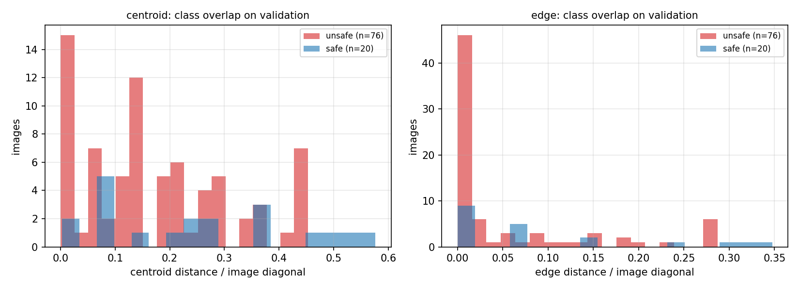
Figure 4: Distance distributions by class on validation. The classes overlap substantially under both measures.
Statistical significance. This is the weakest aspect of the evaluation and is stated plainly. The risk-classification result carries a 95% confidence interval of [0.483, 0.707] around a balanced accuracy of 0.5947, from the normal approximation to the two class recalls on 77 test images. The interval includes chance. The point estimate is above 0.500 and the validation result (0.6705) was more clearly so, but the held-out evidence does not establish that the geometric stage performs better than chance. For the detector results, no variance estimate exists: all runs use a fixed seed with deterministic execution and no configuration was run more than once. Differences of 0.01–0.02 mAP in the ablations therefore cannot be distinguished from seed noise, and comparisons at that magnitude — notably the optimizer ranking — are indicative only. Repeating one configuration across three seeds would establish an error bar and is the single most valuable addition to this evaluation.
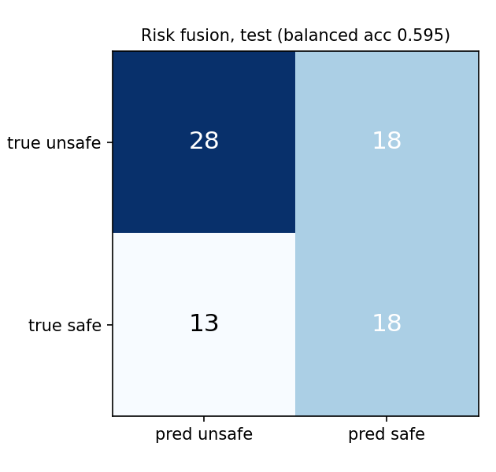
Figure 5: Risk-classification confusion matrix on the held-out test split.
Qualitative analysis. Per-class hazard performance on test ranges from 0.995 (Screwdriver) to 0.168 (Chisel). The spread tracks annotation support rather than intrinsic difficulty: both extremes rest on a handful of instances and are equally unreliable. Among well-supported classes, Coin (0.748), Knife (0.761) and Fork (0.697) perform consistently, while Drink (0.289) underperforms its support — plausibly because the class groups bottles, cups and glasses under one label.
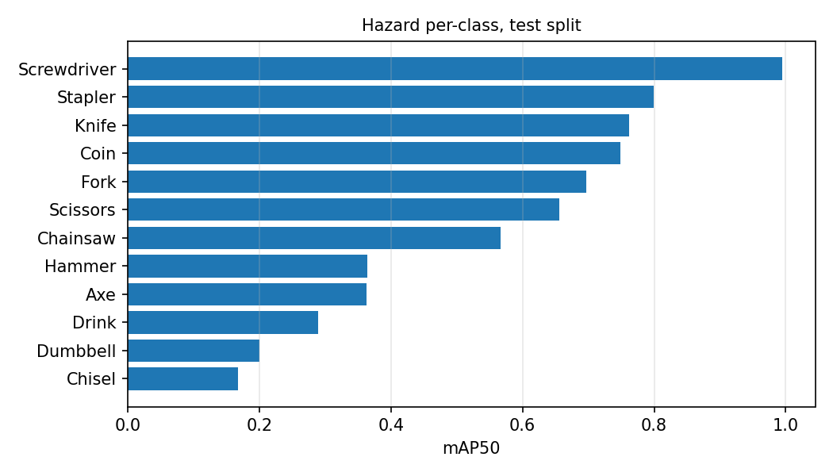
Figure 6: Per-class hazard detection on test. The spread tracks annotation support, not difficulty.
The dominant failure mode is a missed small hazard, which the fusion rule converts directly into a false negative: 28 of 77 test frames had no hazard detected and were labelled Safe without any distance being computed, accounting for most of the 18 false negatives. In a safety application this is the more harmful error direction. A second failure mode motivated the distance-reference ablation: where a child is bent over a small object held in their hands, the child’s box fills much of the frame, so centroid distance reads as roughly 0.4 — apparently distant — while the boxes nearly touch. Nearest-edge distance handles these correctly; that the two measures perform equivalently overall indicates such cases are outnumbered by ones where detection error dominates.

Figure 7: Child detector predictions on validation images.
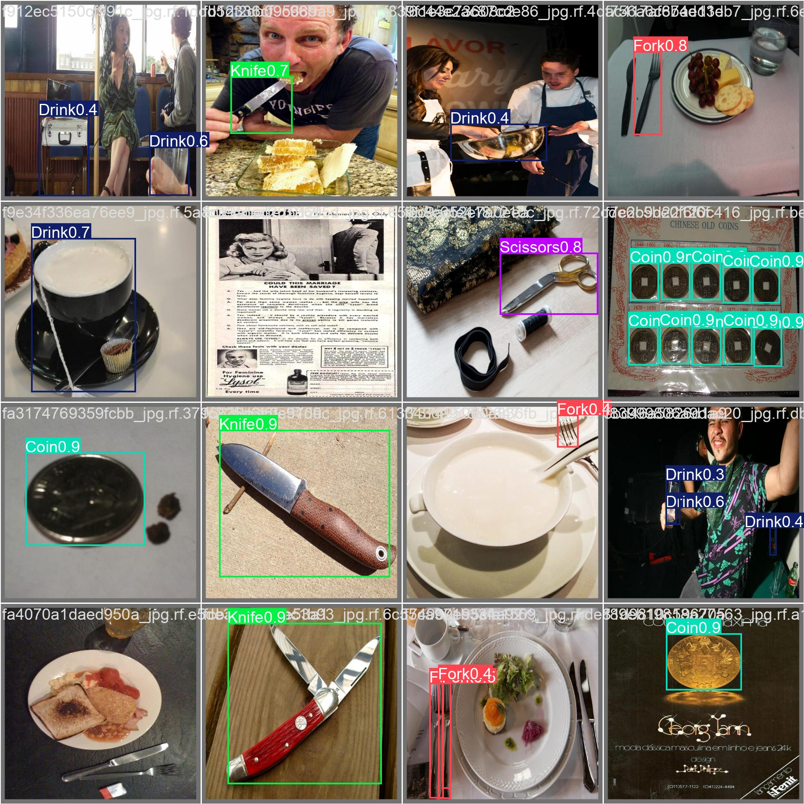
Figure 8: Hazard detector predictions. Small objects at low confidence are the dominant failure mode.
6 Discussion
What the results say. The question was whether two independently trained specialists combined by a geometric rule form a workable risk detector, and at what cost. The answer separates into three parts. The detection stage works and the dual-model cost is negligible: 0.967 and 0.551 mAP50, running together in 7.24 ms per frame, so the concern that motivated the question is not borne out. The geometric stage is not confirmed: balanced accuracy of 0.595 with an interval spanning chance means the proximity rule cannot be claimed to work. And the bottleneck is detection, not geometry — the rule can only act when both objects are found, and the hazard detector misses more than half of them at default confidence. This reframes the problem: the limiting factor is small-object detection under realistic conditions, not the distance formula.
Limitations. The risk evaluation set is composited: hazard crops pasted onto child photographs at controlled separations. This gives exact geometry and non-circular ground truth, but pasted objects have visible boundaries and no lighting or perspective matching, so they test the pipeline’s mechanics rather than establishing that proximity predicts real-world danger. The ground-truth criterion embeds an assumption — “Unsafe” is a gap of at most half the child’s box height, a stated modelling choice, and not a constant physical distance since the dataset annotates a head in roughly 40% of images and a full body in 57%. Seventy-seven test frames is too few to resolve the effect. No variance estimates exist. Hyperparameters, resolution and optimizer were chosen sequentially, each conditioned on the previous winner, and the resolution ablation shows that assumption failing in practice. Both the duplication and the low source diversity in the child dataset bound how strongly generalisation can be claimed.
Ethical considerations. This system must not be presented as a substitute for supervision. Its measured false-negative rate is high — it missed 18 of 46 unsafe frames — and a caregiver who trusts it and reduces direct attention would be worse off than one who does not use it. Any deployment must frame the output as a supplementary alert and disclose the false-negative rate in terms users can act on.
The system also requires continuous camera coverage of spaces where children are, generating exactly the footage that is most sensitive if breached and creating a record of a child’s movements they cannot consent to. On-device processing without retention would mitigate this; the present work does not implement it.
Demographic bias is unmeasured and likely present. The child dataset derives from ~649 web-sourced photographs with no recorded distribution of skin tone, age, body size, clothing or setting. A detector trained on such a set may perform unevenly across groups, and in this application uneven performance means uneven protection — a failure falling hardest on children least represented in the data. We did not measure this, and that omission is itself a limitation; a deployable version would require a demographically documented evaluation set.
Hazard definition is also cultural and contextual: Coin is a hazard for a toddler and not for an eight-year-old, and Drink may be a glass of water. A system that alerts indiscriminately produces false alarms that erode trust, and alert fatigue in a safety system is itself a safety problem. Finally, continuous child-tracking infrastructure can be repurposed for monitoring domestic workers or family members, and the same detect-and-measure pattern generalises to surveillance unrelated to safety.
7 Conclusion
We built and evaluated a child safety risk detector from two independently trained nano-scale detectors and a parameter-free geometric fusion rule. The detectors perform competitively — 0.967 and 0.551 mAP50 on held-out test data — and run together in 7.24 ms per frame, showing that the dual-specialist design carries no meaningful computational penalty at this scale. The risk-classification stage reached 0.595 balanced accuracy with a confidence interval that includes chance, so the geometric rule is not confirmed to work.
The most useful finding is diagnostic rather than architectural. Detection failure, not distance measurement, dominates the error: the hazard detector misses more than half the hazards at default confidence, and each miss becomes a false negative before geometry is consulted. The distance reference — the design question the project set out to examine — proved not to matter, with the ranking between centroid and edge measures flipping according to a detector parameter.
Three methodological results carry beyond this application. Hyperparameters selected on a shortened schedule transferred poorly and reduced final accuracy by 0.040 mAP50, because the learning-rate schedule is defined over the scheduled epoch count. A resolution ablation inverted its conclusion once an earlier hyperparameter was corrected, showing that sequential ablation can give confidently wrong answers. And a widely used framework silently discards a user-specified learning rate under its automatic optimizer setting, invalidating any search run that way.
Future work, in order of expected value:
• Improve small-hazard detection, the binding constraint. A larger backbone, higher resolution for the hazard branch alone, or a detector designed for small objects would address the dominant error directly.
• Build a real, human-labelled co-occurrence evaluation set. Only this can establish that proximity predicts genuine danger rather than constructed geometry, and only this can settle the distance-reference question non-circularly.
• Report variance by repeating configurations across seeds, so the small differences in the ablations can be interpreted at all.
• Treat detector confidence as a tuned parameter, since it affects risk-classification accuracy more than the fusion design does.
• Replace the binary label with a graded risk score, letting the system express uncertainty rather than committing to Safe on a missed detection — the failure mode that currently causes most harm.
ACKNOWLEDGMENTS
Insert paragraph text here.
REFERENCES
[1] Muhammad Haseeb Ahmad, Uzair Ud Din, Fiaz Hussain, Muhammad Farooq, Ahmad Khan, and Ihtisham Ul Haq. 2025. A Computer Vision Based Child Safety Solution Using YOLOv8 Architecture. International Journal of Innovations in Science & Technology 7, 7 (2025), 297–306.
[2] Ahmed K. AlMhdawi, Nonso Nnamoko, and Ahmed M. Ubaid. 2026. Intelligent Spatial Estimation for Fire Hazards in Engineering Sites: An Enhanced YOLOv8-Powered Proximity Analysis Framework. arXiv:2603.09069.
[3] Roman Solovyev, Weimin Wang, and Tatiana Gabruseva. 2021. Weighted boxes fusion: Ensembling boxes from different object detection models. Image and Vision Computing 107 (2021), 104117.
[4] Nur Ramadan, Muhammad Muhtadi, Muhammad Z. Rafi, and Retno E. Waluyo. 2025. Risk Detection System for Children Putting Objects into Mouth Based on Computer Vision using YOLOv11n. Indonesian Journal of Innovation Studies 26, 4 (2025).
[5] Farhan A. Khan and Anup Dey. 2024. Towards enhancing child safety: A deep learning approach to detect child safe and unsafe objects. In 2024 IEEE International Women in Engineering (WIE) Conference on Electrical and Computer Engineering (WIECON-ECE). IEEE, 123–128.

